 Week 5:

CREATE TABLE SubjectAllotments (

StudentId VARCHAR(50),

SubjectId VARCHAR(50),

Is_Valid BIT

);

CREATE TABLE SubjectRequest (

StudentId VARCHAR(50),

SubjectId VARCHAR(50)

);

--procedure

CREATE PROCEDURE sp_ProcessSubjectRequests

AS

BEGIN

DECLARE @StudentID VARCHAR(50);

DECLARE @RequestedSubjectID VARCHAR(50);

DECLARE request_cursor CURSOR FOR

SELECT StudentId, SubjectId FROM SubjectRequest;

OPEN request_cursor;

FETCH NEXT FROM request_cursor INTO @StudentID, @RequestedSubjectID;

WHILE @@FETCH_STATUS = 0

BEGIN

DECLARE @CurrentSubjectID VARCHAR(50);

SELECT @CurrentSubjectID = SubjectId

FROM SubjectAllotments

WHERE StudentId = @StudentID AND Is_Valid = 1;

IF @CurrentSubjectID IS NULL

BEGIN

INSERT INTO SubjectAllotments (StudentId, SubjectId, Is_Valid)

VALUES (@StudentID, @RequestedSubjectID, 1);

END

ELSE IF @CurrentSubjectID <> @RequestedSubjectID

BEGIN

UPDATE SubjectAllotments

SET Is_Valid = 0

WHERE StudentId = @StudentID AND Is_Valid = 1;

INSERT INTO SubjectAllotments (StudentId, SubjectId, Is_Valid)

VALUES (@StudentID, @RequestedSubjectID, 1);

END

FETCH NEXT FROM request_cursor INTO @StudentID, @RequestedSubjectID;

END

CLOSE request_cursor;

DEALLOCATE request_cursor;

END;

--Insertion

-- Existing subject allotments for a student

INSERT INTO SubjectAllotments VALUES ('159103036', 'PO1491', 1);

INSERT INTO SubjectAllotments VALUES ('159103036', 'PO1492', 0);

INSERT INTO SubjectAllotments VALUES ('159103036', 'PO1493', 0);

INSERT INTO SubjectAllotments VALUES ('159103036', 'PO1494', 0);

INSERT INTO SubjectAllotments VALUES ('159103036', 'PO1495', 0);

-- Student requests a new subject

INSERT INTO SubjectRequest VALUES ('159103036', 'PO1496');

--Preview

Select * from SubjectAllotments;

Select * from SubjectRequest;

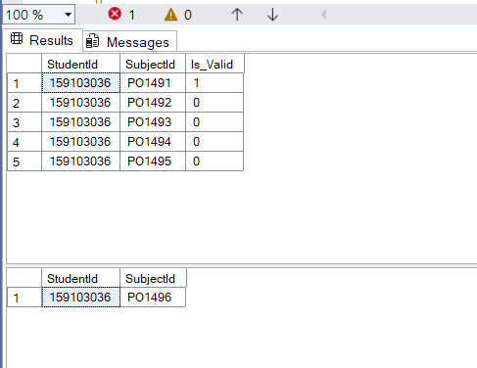

--Execution

EXEC sp_ProcessSubjectRequests;

